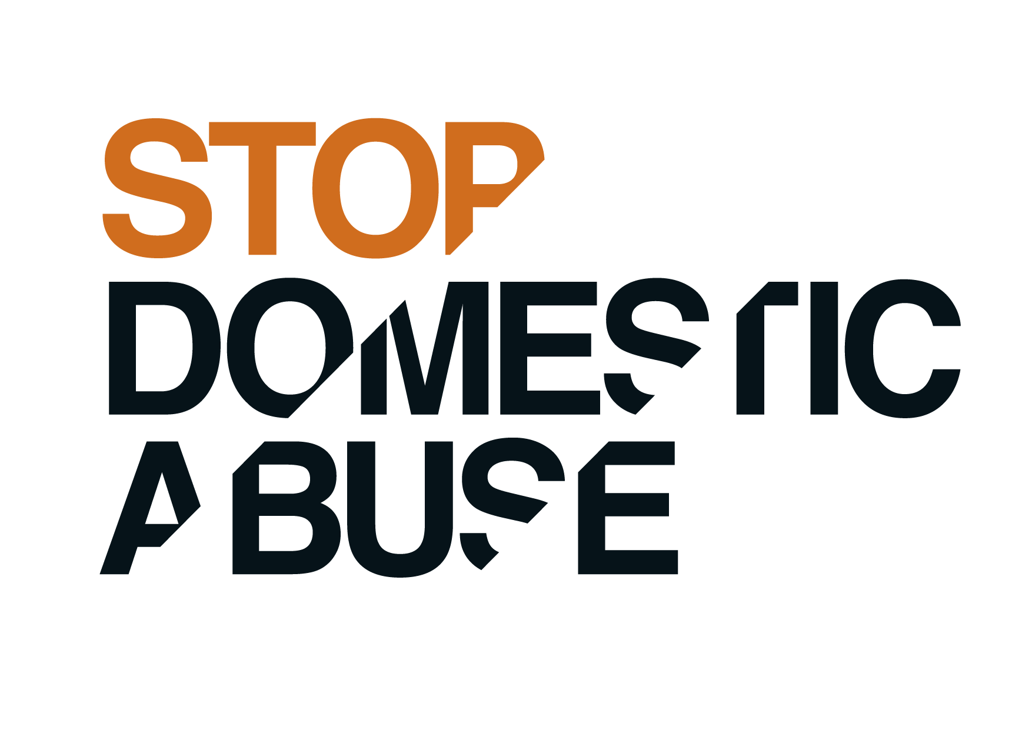
Job description

JOB TITLE:
Female* Outreach Project Worker (Children and Young People)
Victim Service West
*This post is open to female applicants only as being female is deemed to be a genuine occupational requirement under Schedule 9, Paragraph 1 of the Equality Act 2010.

Salary: £21,121 per annum 15-16 hours a week

This is a fixed term contract until 30/09/20

Workers should be “violence free in their own lives.”
Applicants are asked not to put themselves forward for selection if this is not the case.

MAIN PURPOSE AND SCOPE OF THE JOB

- To provide support, advice and assistance to children and young people who have experienced domestic abuse living in the community and in refuge.

- The work will focus on preventing domestic abuse and breaking the cycle of abuse by providing support for children and young people in the refuge and in the community and supporting children and young people to keep safe.

- Work to empower and support children/young people to make positive choices.

- To provide holistic one to one support including exploring healthy relationships, expressing emotions, safety, wellbeing, education and family relationships.

- To provide parenting support to women living in the refuge and Stop Domestic Abuse clients/parents of clients living in the community.

- Providing group work for adults, families, children and young people.

- The post-holder work as part of the refuge team, with families who live in the refuge, families who have moved out of the refuge and children and young people who are referred via the Front Door Service.

- To work in partnership with voluntary and statutory sector organisations and the community; attend meetings and events including in the evenings and at weekends.

POSITION IN ORGANISATION

Reports To: Deputy Service Manager West
Responsible For: N/A
Budget Responsibilities: N/A
Hours: 15-16 hours a week; this will include evening work and weekend work on a rota basis
Location: Stop Domestic Abuse currently covers the whole of Hampshire, including Portsmouth. Our Head Office is based in Havant. This post is currently based in Winchester District.
The post-holder may be based at more than one site

DUTIES AND KEY RESPONSIBILITIES

Supporting Children and Young People

- To ensure that the needs of the children and young people who have experienced, or are experiencing, domestic abuse are met. This will be done by:
- Providing group work
- Providing workshops
- Providing parenting and family support
- Providing one-to-one services to children/young people living in the community and refuge accommodation, including safety planning
- Supporting children to be free from domestic abuse/sexual exploitation
- Providing advocacy and support for children/young people
- Providing holiday activities
- Delivering age-appropriate structured and free play activities
- Supporting children and young people to access and maintain education
- Welcoming women and their children into the refuge and providing them with support to meet their practical and emotional needs
- Identifying behaviours that may put the child/young person at increased risk of victimisation or offending and delivering interventions to target these.
- Working with children/young people to identify the impact of witnessing domestic abuse and strategies for coping
- Working with schools to increase attendance and reduce exclusion and supporting children and young people to access and maintain education
- Working in partnership with Social Services, Education, Health, Police, Community Safety and voluntary organisations etc to ensure that children and young people using our services have the best possible support and opportunities
- Signposting and referring parents to services available to support them
- Supporting other agencies to provide improved responses to domestic abuse and sexual abuse

- To represent the needs of children and young people; both in the refuge and the wider community.

- To provide children and young people with on-going advice and support. This includes one to one support, group work, work in schools and work in community centres etc.

- To provide group work for residents and children living in the refuge.

- To identify and care for the emotional and educational needs of the children and young people in the refuge and the wider community.

- To help children begin the healing process of working through their traumatic experiences of domestic abuse and change. This will be done by:
- Facilitating interaction between children and young people
- Encouraging children and young people to support each other
- Helping children and young people develop a positive attitude to life
- Supporting children and young people to deal with anger and discipline without violence
- Supporting children and young people through a range of emotions and with a range of difficult issues
- Working with a variety of media to support children and young people’s understanding of a healthy relationship

- To work with children and young people who move on from the refuge with resettling into the community by providing on-going support on an outreach basis and providing support to prevent repeating patterns of abuse.

- To work with children and young people living in the community who are experiencing or have experienced domestic abuse. To provide one to one services offering practical and emotional support and advocacy etc.

- To facilitate educational transfers and liaison with schools etc.

Partnership working and representing Stop Domestic Abuse

- To establish and maintain links with statutory and voluntary agencies; in order to promote and support the welfare of children and young people who have experienced domestic abuse.

- Form and maintain relationships with local specialist domestic abuse services; to enable successful referrals of victims and survivors, for continuing support, advice and assistance.

- To develop effective relationships with relevant local organisations to raise the profile of domestic abuse and its impact on families and to publicise the support networks.

- To advocate for children and young people who have experienced or are experiencing domestic abuse. This includes advocating with a number of agencies or individuals such as education, families, siblings, Social Care, community groups and Police etc.

- To work with other local organisations and groups, through partnership, to establish a safe and accessible place for young people to meet in the community and to provide and facilitate support to prevent domestic abuse.

- Support colleagues and partner agencies, through awareness raising and institutional advocacy, in order to provide the best possible service for victims of domestic abuse.

Safeguarding and protection from abuse

- To make sure that child welfare is ensured in accordance with Stop Domestic Abuse Protection from Abuse Policy and the Local Safeguarding Children Board policies and procedures.

- To ensure that a high standard of information and advice is provided to all victims and survivors of domestic abuse.

- Remain up-to-date and compliant with all organisational procedures, policies and professional codes of conduct and uphold standards of best practice.

- Lone working
- To follow the Stop Domestic Abuse’s Lone Working Policy and Procedure.
- Undertake risk assessments in liaison with Managers and other team members re: home visits and neutral location meetings.

- Diversity
- To facilitate access to interpreters and adjust interview practice accordingly
- To work towards the safety/needs of diverse cultural and ethnic groups, also health, mobility, sexuality etc. Form links with relevant agencies to do this.
- Work flexible hours i.e. evening and weekends where necessary to be flexible as to when the non-abusive partner can meet/be contacted.
- Respect and value the diversity of the community in which the service works in, and recognise the needs and concerns of a diverse range of survivors ensuring the service is accessible to all.

Administration and Record keeping

- Ensuring that all relevant records are kept accurately and in a timely manner, both on paper and electronically.

- To write accurate and concise reports and case studies.

- Undertaking administrative and financial tasks and maintaining full records and receipts for all activities. This will include issuing licence agreements, collecting rents and service charges, and assisting clients in completing applications for school admissions, housing and benefits.
- In accordance with Stop Domestic Abuse’s case management policy: be proactive with your line manager in carrying out periodic case reviews based on a review of risk and abuse which:
  - Feeds back into action planning to further progress, signpost or close cases and;
  - Provides feedback to your clients/agencies.

- Help maintain accurate and confidential records using our secure web-based case management database and contribute to monitoring information for the service.

- Comply with data protection legislation, confidentiality and information sharing policies and procedures and all legislation connected to your work.

- To contribute to the evaluation of the service by:
- Ensuring that evaluation information is properly recorded and forwarded to those managing programme evaluations

- Training
- To undertake training as required
- Give presentations and provide information to local agencies
Supporting the parent child relationship

- To work in partnership with the parent regarding particular needs of their children. To provide support to parents in promoting the parent/child relationship.

- To ensure that a high standard of information, advice and temporary accommodation is provided for women and their children who have suffered domestic abuse.

- When refuges are full, to find alternative accommodation for women, children, young people and men.

- To provide advice by telephone and face to face; to assist women, children, young people and men experiencing domestic abuse to understand the services available and make choices about their own future.

GENERAL RESPONSIBILITIES

- To participate in fundraising activities on behalf of Stop Domestic Abuse.

- To undertake administrative and financial tasks and maintain full records and receipts for all activities. This will include assisting clients in completing applications for housing, legal support and benefits.

- To publicise the support available to women, children, young people and men at risk of domestic abuse.

- To record and maintain up to date statistics of enquiries and referrals.

- Monitor and evaluate the project.

- To attend Management Committee meetings if required.

- To work with volunteers.

- To establish effective working relationships with colleagues in other services including education, Social Services, the local authority, police and voluntary agencies; assisting to increase their understanding of domestic abuse issues, taking and making referrals and acting in an advocacy role as necessary.

- To participate as a member of the Stop Domestic Abuse’s staff team; including regular attendance at team and other meetings, supervision and appraisal sessions, training and other events as may be required.

- To be available to respond to emergencies outside office hours, on a rota basis.

- To ensure the confidentiality of client information is maintained, in accordance with the Stop Domestic Abuse Confidentiality Policy.

- To assist with providing cover for absent colleagues during periods of sickness, holidays etc, as requested by the CEO and/or Service Manager.

- To be available to participate in the on-call rota for the out of hours service.

- To advise the Manager on the purchase of educational and play materials.

- To ensure residents participation in cleaning of communal areas thus ensuring a good standard of hygiene is maintained in the refuge. To ensure preparation of vacant rooms ready for re-letting. To participate in the cleaning of communal areas and vacant rooms personally if required.

- To participate in gardening and general maintenance of the refuge buildings to ensure that the premises are safe and to a high standard for all those who use it. This may include referrals to other organisations, however personal participation will be required.

- To work within the confines of confidentiality, the staff Code of Conduct and Professional Boundaries policies, in working with clients, colleagues and external agencies. To ensure the security of sensitive information is maintained.

- To carry out other such duties as appropriate to the scope and grade of the post, as may be requested from time to time to meet the needs of clients and the service.

This job description is a new role and sets out the duties of the post at the time when it was drawn up and will be reviewed after six months. Duties may vary from time to time without changing the general character of the duties or the level of responsibility entailed. Such variations are a common occurrence and cannot of themselves justify a reconsideration of the grading of the post.

Person Specification
Female* Outreach Project Worker (Children and Young People)
*This post is open to female applicants only as being female is deemed to be a genuine occupational requirement under Schedule 9, Paragraph 1 of the Equality Act 2010.
Criteria  E = Essential  D = Desirable |  | E or  D
Skills and Abilities | The ability to build rapport quickly with women, children, young people and men participating in the service.  The ability to work constructively with the parent/guardian and their children in order to foster their relationships.  A commitment to the empowerment of children and young people.  A commitment to equal opportunities.  The ability to liaise effectively with a wide range of agencies.  Organisational skills and the ability to prioritise work on a daily basis.  The ability to work as part of a team and on one’s own initiative.  Numeric and literacy skills to undertake administrative tasks.  Computer Literacy.  Effective communication skills.  Ability to work flexibly and some unsocial hours.  The ability to facilitate groups.  The ability to develop and promote projects in the community.  The ability to manage your own caseload.  Good Presentation Skills.  Ability and willingness to represent the programme positively to other community agencies.  Strong commitment to anti-oppressive practice and working with diversity.  Good self management skills and above average ability to take initiative and problem solve.  Ability to be flexible regarding tasks given, to work as a team to achieve a common goal and willingness to participate in general cleaning, gardening and basic maintenance of the refuge buildings to ensure a high standard to living environment for the families. | E  E  E  E  D  E  D  E  E  E  E  E  E  E  E  E  E  E  E
Experience | Experience of providing support to young people and children under stress and who are vulnerable.  Experience of working with and advocating for children and young people.  Experience of developing new services for children and young people.  Demonstrable experience of supporting individuals within the context of a helping environment, both face to face and on the telephone.  Experience of facilitating support groups and targeted group work.  Experience of taking personal responsibility for specific projects/work areas, devising work plans and their implementation.  Experience of working with a diverse range of people, including those experiencing deprivation. | E  E  D  E  E  D  D
Knowledge | An understanding of and a commitment to the principles of Stop Domestic Abuse.  An understanding and awareness of the needs of women, men and children of all ages who have experienced domestic violence and abuse.  An understanding of the complexities of partnership working and a commitment to partnership working.  An understanding of safe lone working practices  An understanding and knowledge of child protection and safeguarding and the ability to work within national, local and organisational guidelines.  An understanding of and ability to practice confidentiality.  Awareness of the legal and housing issues affecting families escaping domestic abuse.  Ability to use reflective listening with empathy and respect.  Ability to use supervision effectively.  Ability to support change through coaching and constructive feedback.  Ability to work in partnership with children/young people and deliver support in ways that meet identified needs. | E  E  D  E  E  E  D  E  E  E  E
Qualifications | A clean driving licence and car owner.  A levels or above.  A relevant qualification for working with children/young people.  Ability to work at NVQ (or equivalent) level III.  Further Education Qualification. | E  D  D  E  D
Personal Attributes and Other requirements | Personal Qualities  Ensuring Equal Opportunity.  Emotional Intelligence.  Commitment to user-focused services.  Commitment to self development.  Good standards of hygiene and personal presentation.  Be compassionate and empathetic with your client’s situation.  Show initiative and be proactive when managing your case load and interacting with your clients and agencies you’re working with.  Act with integrity and respect when working with all clients, agencies and individuals.  Be optimistic about the possibility of personal growth and change.  Motivate individuals and agencies to move through courses of action and decision making processes.  Awareness of professional boundaries.  Other Requirements  The post is based in the refuge and in the community.  The post is a full time job.  There is a requirement for early morning/evening work in this job.  There is a requirement for weekend work in this job.  To be available to participate in the on-call rota for the out of hours service.  The work of Stop Domestic Abuse can require the distribution and transportation of materials, literature, display equipment, etc and, therefore, the post holder must be fit to lift normal boxes of stationery, minor equipment and carry same.  An enhanced DBS (Disclosure and Barring Service) disclosure will be required for this role. | E  E  E  E  E  E  E  E  E  E  E
February 2019

